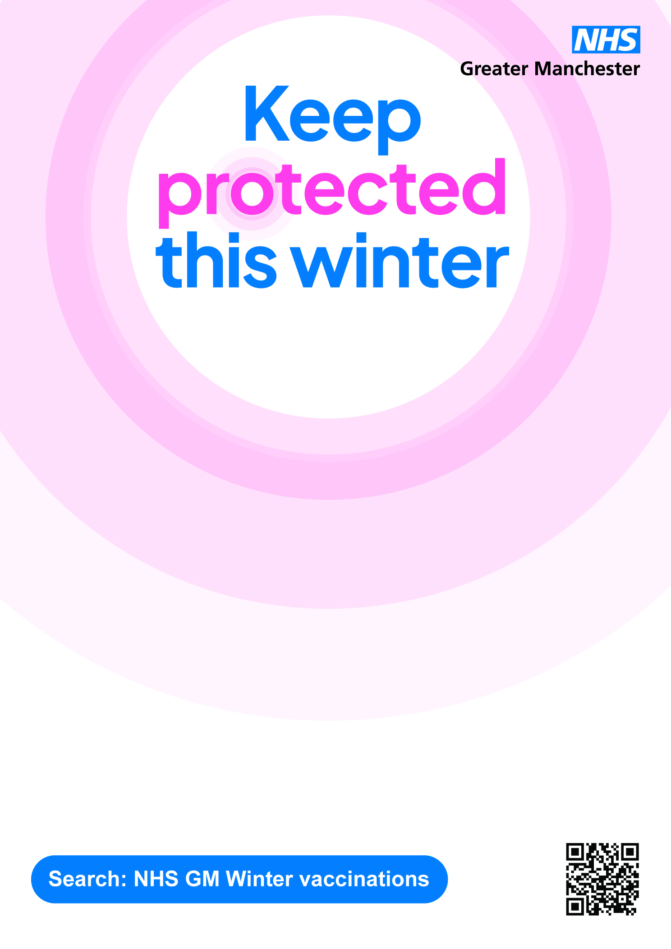
Mobile Outreach Service
Delivering covid and flu vaccinations as well as blood pressure checks across the Wigan Borough – in Leigh on various dates/sites:
Saturday, 1st November 2025 – Trees Estate, Briar Grove, Westleigh WN7 5
Friday, 14th November 2025 – Hope Carr Road, Leigh WN7 3ET by Vision Food & Wine
Saturday 6th December 2025 – Spinning Gate Car Park, 116 Bradshawgate, Leigh WN7 4NP

